25th April 2016

**Rain, a protagonist at WTCC Race of Hungary**

**\*Tensions rise at Hungaroring following Huff/Muller clash**

**\*Lopez leads Championship again**

Tensions were high at the Hungaroring at the weekend’s FIA World Touring Car Championship. The race of Hungary which had promised so much and created so much expectation, especially with the home hero, Norby Michelisz aiming high, did live up to the excitement, although not to the content of the local fans, due mainly to technical trouble for Michelisz’s car who was already unable to complete the formation lap in the opening race and had to return to boxes for repairs.

The appearance of rain, meant tactical choice of tyres, whether wet or slicks, impacted the end result. With the Japanese Tyre manufacturer YOKOHAMA as Official Tyre supplier to the World Championship, spirits were high at the qualifiers and the Honda/Citroen battle was heating up.

The opening race was clearly determined by the weather and specs of rain that began as soon as the warm-up lap had started. Wise choice or clever gamble from Mehdi Bennani, from Sebastien Loeb Racing team who decided on wet tyres and achieved a superb victory leading from beginning to end. In second Bennani’s team mate Tom Chilton also steamed forward from P10, past the other drivers who had taken slicks to obtain the runner-up place in the podium and big smiles in Loeb Racing. In third Nicky Catsburg from Lada, managed a meritorious third place and his second podium in the Championship. In fourth, Volvo Polestar’s Fredrik Ekblom for the Swedish make’s best WTCC finish so far. The top guns had gambled and lost.

The main race was a different story for the factory teams, although by no means easy. Current Champion Jose Maria Lopez was in a fierce battle with Rob Huff from Honda, and Citroen team mate Yvan Muller throughout the race. Bumper to bumper action and dramatic turns and surprises at every corner. At the end of the race, Lopez described it as “one of the toughest” he’s had.

Muller had started well from P7 and quickly gained the third place with sheer skill and speed and overtook Huff to gain second place in turn 5, just before the safety car was called in due to an accident from Demoustier on the third lap – fortunately he was un-injured. Huff then gained ground and felt his Honda had more speed than Muller’s Citroen and went all out for it, only to hit Muller’s car and then ordered a drive-through as penalty. The mood was tense and it remains to be seen how the incident will have an effect on the remaining 9 race weekends of the World Championship. Huff eventually managed a very honourable sixth place. Huff’s Honda team mate, Thiago Monteiro however kept the chase and took benefit from Huff’s drive-through to eventually cross the checkered flag in third behind Muller and gaining valuable points for the Championship.

**With the next race weekend in Morocco 6th-8th May 2016 the Drivers Championship is as follows;**

Jose Maria Lopez 106

Thiago Monteiro 94

Mehdi Bennani 77

Rob Huff 60

Yvan Muller 54

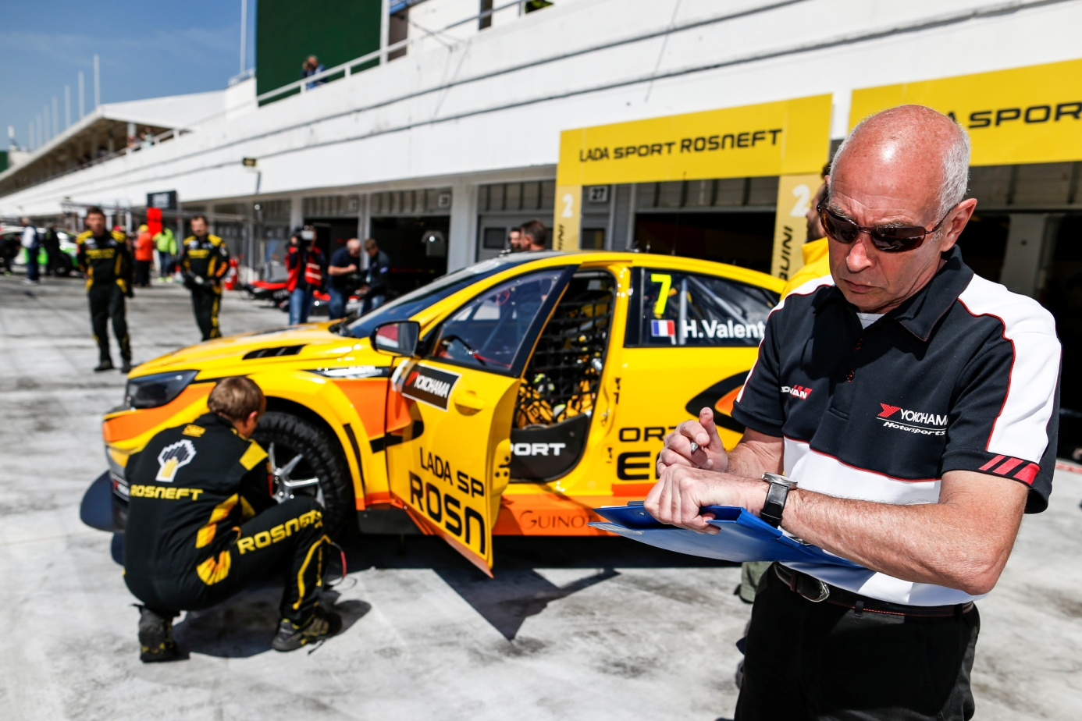

*Yokohama Motorsports support team member focuses on detail*

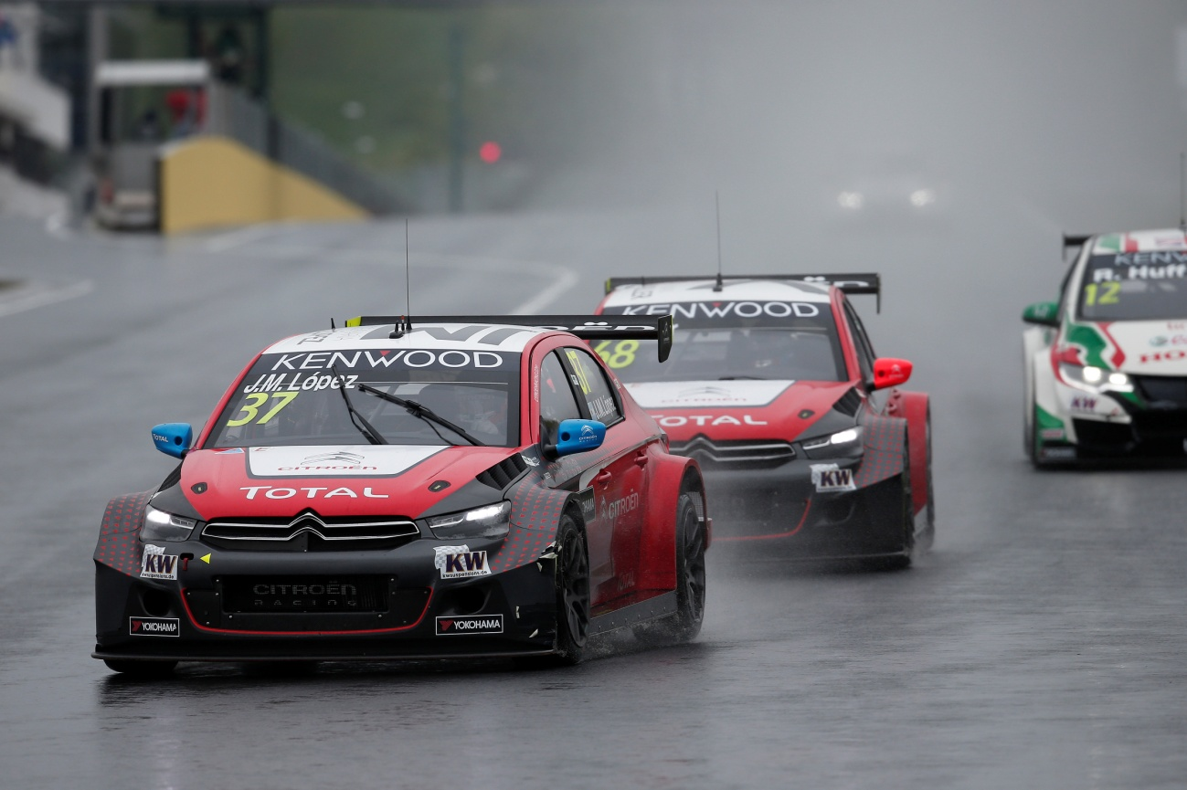

*Lopez wins in the rain ahead of Muller and Monteiro*

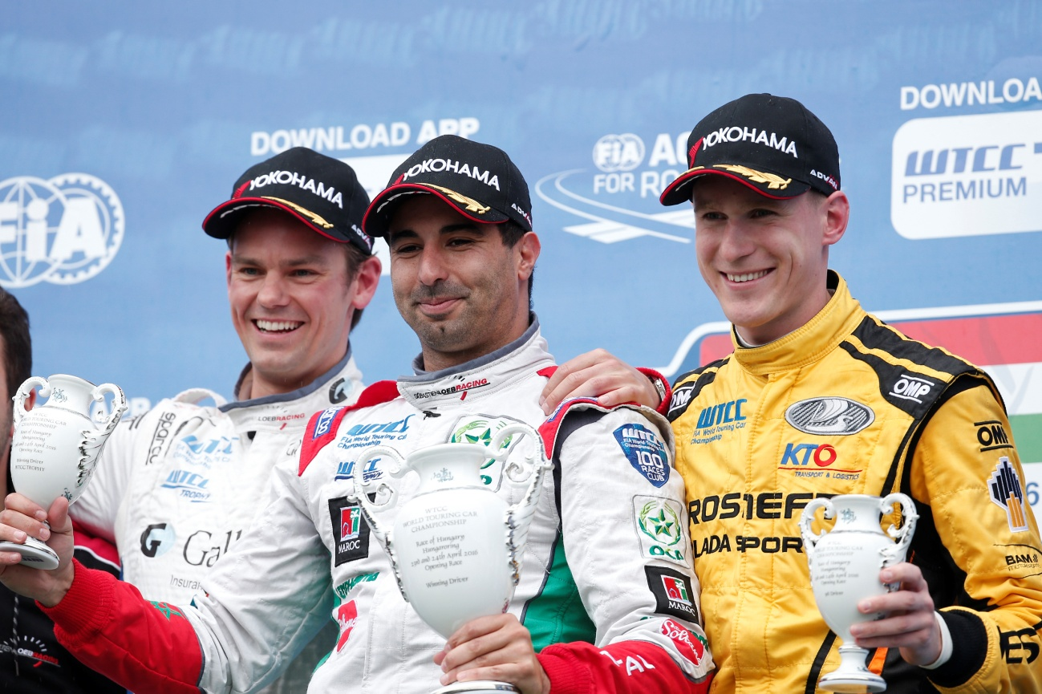

*Opening Race of Hungary Podium with Bennani, Chilton and Catsburg*